**U18ISI6204 – Machine Learning Techniques**

# LAB EXPERIMENT- 3

# Name: Navina G A

# Roll no: 20BIS028

**Multiple Linear Regression:**

import pandas as pd

import numpy as np

import matplotlib.pyplot as plt

import seaborn as sns

df = pd.read_csv("C:\\Users\\spd85\\Downloads\\abc\\data.csv")

df.head()

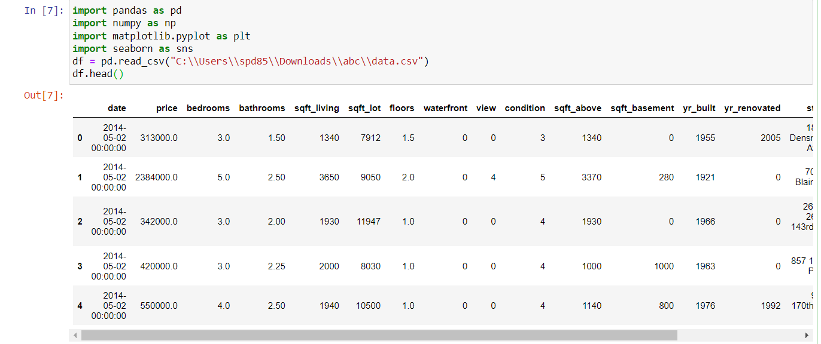

print(df.info)

df.describe()

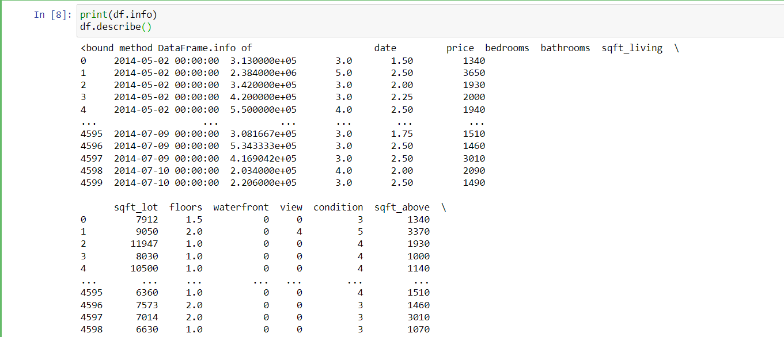

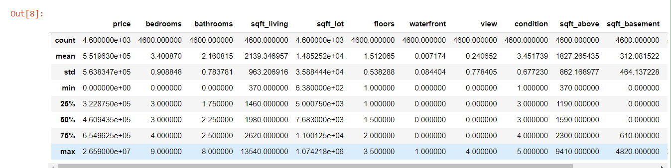

sns.heatmap(df.corr(),annot=True)

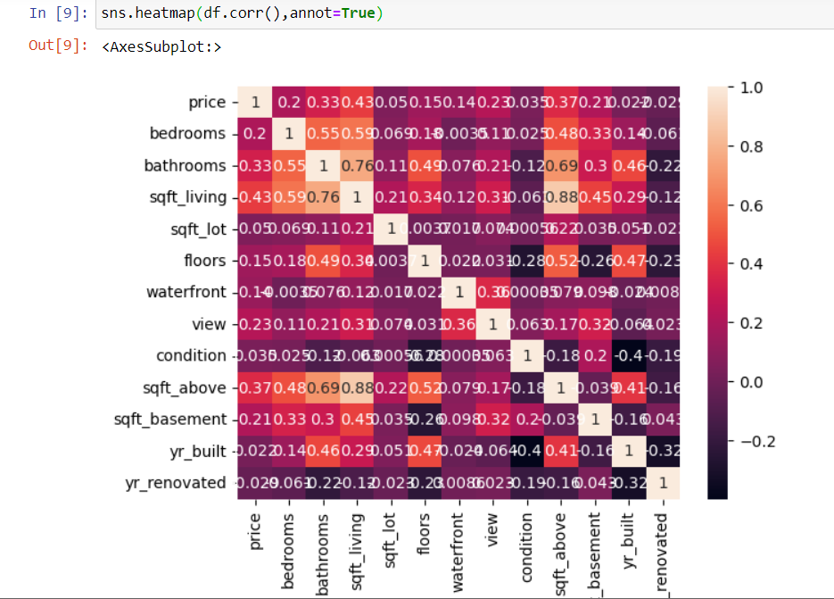

X = df.iloc[:,2:32]

print(X.shape)

X.head()

y = df.view

print(y.shape)

y.head()

from sklearn.model_selection import train_test_split

X_train, X_test, y_train, y_test = train_test_split(X, y, test_size=0.25, random_state=4)

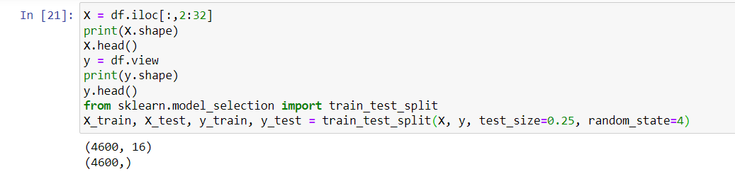

refined_cols = ['sqft_living','sqft_lot','sqft_above']

from sklearn.linear_model import LinearRegression

MultiLR = LinearRegression()

MultiLR.fit(X_train[refined_cols],y_train)

y_pred = MultiLR.predict(X_test[refined_cols])

from sklearn.metrics import mean_squared_error,r2_score

print('MSE',mean_squared_error(y_test, y_pred))

print('r2',r2_score(y_test,y_pred))

